Contact:
Bob Tarren with MAD/Murphy Arts District
870-863-4547 • bobt@eldofest.com
or
Beth Brumley with Main Street El Dorado
870-862-4747 • director@mainstreeteldorado.org

PRESS RELEASE -- FOR IMMEDIATE RELEASE

The Murphy Arts District & Main Street El Dorado present the

2018 Murphy USA Summer Concert Series
  - Saturday June 23rd • July 28th • August 25th
FREE in Downtown El Dorado AR

Fun Free Events all summer long in El Dorado with the Murphy USA Summer Concert Series

EL DORADO, ARK.,— Starting this weekend and continuing all Summer, celebrated vocalists, award-winning performers, and national touring acts from multiple genres and music scenes will be making their way to the heart of Downtown El Dorado for the 2018 Murphy USA Summer Concert Series, presented by MAD and Main Street El Dorado.
The Murphy USA Summer Concert Series will be held outdoors at the MAD Amphitheater following a full day of activities lined up downtown featuring monthly Grill contest on the courthouse lawn, classic car cruises around the downtown square, free horse and carriage rides, kids activities in the all new MAD Playscape and Splashpad and El Dorado’s award winning legendary Showdown at Sunset performances on the fourth Saturday of June, July and August. The rollicking reenactment of the Tucker-Parnell feud will be performed on the steps of the Union County Courthouse beginning at 6 p.m. The Murphy USA Summer Concert Series will have a new location at the MAD Amphitheater (105 Locust St. El Dorado AR. 71730) in Downtown El Dorado. Opening acts begin at 7 p.m., with headliners taking the stage at 8 p.m.
“Main Street El Dorado has been entertaining crowds with Showdown at Sunset for many years, joining that successful event with the Murphy USA Summer Concert Series seven years ago. We’re very excited to partner with the Murphy Arts District for this year’s Murphy USA Summer Concert Series to make this event bigger than it ever has been capitalizing on their level of successful events in El Dorado” said Beth Brumley, Executive Director of Mainstreet El Dorado. “they add the ability to bring even bigger stars to the Murphy USA Summer Concert Stage for three free, outdoor concerts, and we can’t wait to share them with the whole region.”
Kicking off on Saturday June 23rd featuring Dance Innovator and double platinum hip-hop artist,
NEW CUPID
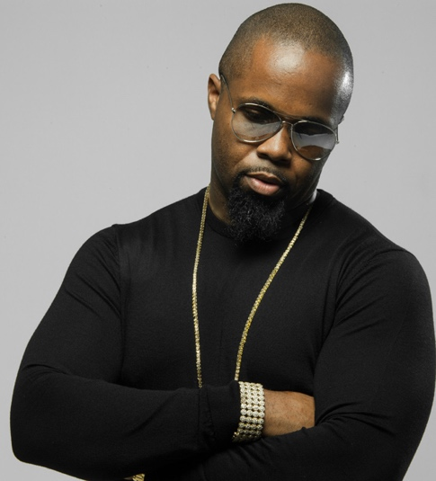
New Cupid is a world-wide performer, double platinum recording artist and creator of the global phenomenon "The Cupid Shuffle". In 2007, new cupid shuffled his way into the hearts of millions with the up-tempo party song "cupid shuffle," which inspired the popular dance craze. From appearances on nationally syndicated TV and radio talk shows such as Dr. OZ, Steve Harvey and Tom Joyner to breaking the Guinness Book of World Records for the largest line dance assembled with over 17k people, cupid has virtually reshaped dance music and created an entirely new genre.

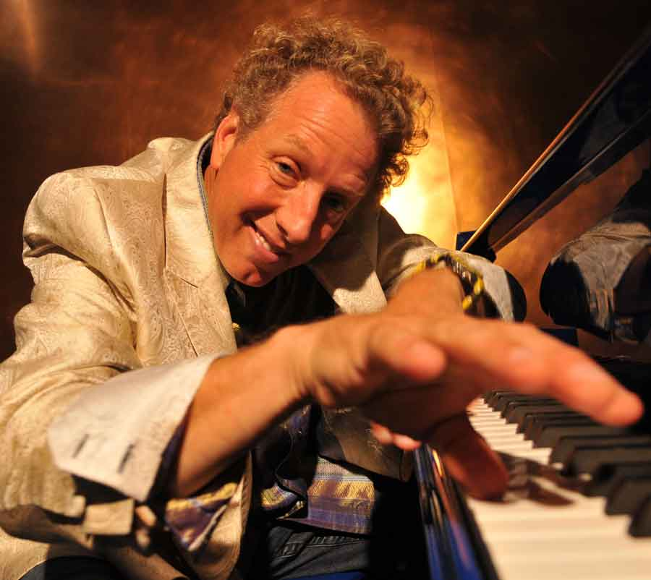
Continuing Saturday July 28th featuring local son and legendary Sun Records star,
JASON D. WILLIAMS
Known for his high-energy shows and love of live performance, Williams brings rock and roll back to its boogie woogie roots. His wild piano playing will bring to mind great performers like Jerry Lee Lewis and Al Jolson, while his personality remains 100-percent original. There’s no such thing as a bad show for this seasoned performer, who tours more than 160 shows a year.

Artist for final concert of the summer, on August 25, is still to be announced.
EVENTS!
In addition to the Murphy USA Summer Concert Series performances, come for a full day of fun in Downtown El Dorado featuring: GRILL WARS grilling contest on the courthouse lawn starting at 10am, BAGGO Tournament at 11am, the all new MAD Playscape and Splash Pad for the KIDS, Free Horse and Carriage rides around the square 3-7pm, Classic Car Cruise Night around the square at starting at 4pm followed by the Award Winning SHOWDOWN at SUNSET at 6pm on the Union County Courthouse lawn and The Murphy USA Summer Concert Series at 7pm in the MAD Amphitheater.

- All Events are Free except the Grill Wars cook-off and Baggo Tournament which require an entry fee to compete for prize packages.
CONTACT!
For more information visit www.eldomad.com
Bob Tarren with MAD/Murphy Arts District
870-863-4547 • bobt@eldofest.com
Or
www.mainstreeteldorado.org
Beth Brumley with Main Street El Dorado
870-862-4747 • director@mainstreeteldorado.org

Event Location:
Downtown El Dorado events held on the Union County Courthouse lawn:
101 N. Washington Ave., El Dorado AR. 71730

Concert events held right around the corner at the MAD Amphitheater:
105 Locust St. El Dorado AR. 71730

Sponsors for the event include: Noalmark Broadcasting, KTVE NBC 10, The South Arkansas Historical Preservation Society and the El Dorado Advertising and Promotions Commission.
Concertgoers are encouraged to spend the day in downtown El Dorado, exploring all that’s available within walking distance of the outdoor music venue. Restaurants and boutiques line Union Square, many offering specials for the weekend, and there will be plenty of additional festivities as listed above during each event.
###

